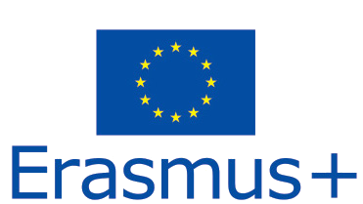

Educational for Drone (eDrone)
(Project Number 574090-EPP-1-2016-1-IT-EPPKA2-CBHE-JP)

WP1, D1.3
Visit to enterprises

Deliverable Type | Report
Result
Date of Delivery | 25.07.2017
Author(s) | P4 – Military University of Technology
Reviewer | Tatiana BULIMAGA
Review date | 30.11.2017
Reviewer | Victoria JITARI
Review date | 03.12.2017

Table of content
Table of content 2
Versioning and Contribution History 4
Introduction 6
Surveys from visited enterprises 9
Armenia 10
Instigate Robotics 10
Airworker LLC 13
Belarus 15
Design Bureau “Independent Development Laboratory” TM 15
Scientific and Engineering Republican Unitary Enterprise „ Geoinformation Systems” 17
Georgia 20
LTD Copter 20
Moldova 23
Icevo Consulting SRL 23
Temporary publishing house «Молдавские ведомости» SRL 26
Tourism Agency of the Republic of Moldova 28
Ministry of Transports and Road Infrastructure 30
S.E „Institute of Development and Forest Research” 32
State Border Police of the Republic of Moldova 34
Glia-Vito ltd 38
Vindex-Agro ltd 39
S.C. Nova-Geea ltd 41
Crama Domnească Ltd 43
SC Agro Girla ltd 45
Dîngenarul Ltd 47
„Vivaj-Agro” ltd 48
Program Countries 50
Skydrone 50
SterKom Piotr Kleczyński 52
SC AFT DESIGN SRL 55
Overview of visited enterprises 59
Enterprises by category 61
Drone production 62
Aerial Photography 64
Agriculture 65
Public Administration 66
Enterprises by country 67
Armenia 67
Belarus 67
Georgia 68
Moldova 69
Program Countries 72
Conclusion 73

Versioning and Contribution History

The following is the document control for revisions to this document.

Version | Date | Reason | Modified by
1 | 25.07.2017 | Submission of the report to WP5 leader | Bartosz Brzozowski
2 | 16.12.2017 | Modifications of the report after reviews | Bartosz Brzozowski

Please include here also information on: when was the concept note submitted, when was feedback received, etc.

Project Number: 574090-EPP-1-2016-1-IT-EPPKA2-CBHE-JP

Project Acronym: eDrone

Result: WP1 – User Needs and State of Art Analysis

Deliverable number and title: D1.3 – Title of Deliverable

Type of deliverable: Report

Required date of delivery: 14.07.2017
Date of last version delivery: 16.12.2017
Work package: WP1
Lead responsible partner: P4 – Military University of Technology
Responsible person: Bartosz Brzozowski
Other cooperating partners: All
Total number of pages: 75

Elaborated by:
Bartosz BRZOZOWSKI, P4 - MUT

Introduction

This report is the Outcome 1.3 from Work Package 1 – Preparation: “User needs and State of Art”. It summarizes visits to enterprises to Program and Partner Countries companies producing high-tech solutions for drone fields and companies interested in using drones in their activities.
In order to figure out a strategy aimed at joint actions to introduce leading-edge technology in civil application of drones, the Partner Countries involved in the proposal need to have an insight of the technological knowhow held in local enterprises of the sector. Short visits to Program and Partner Countries companies producing high-tech solutions for drone fields and companies interested in using drones in their activities were arranged to build up connection and foster cooperation with academic world. All this in accordance with the goals of the European general objective aiming at empowering the new competences and so new job opportunities, in particular for young people, as encouraged by Europe 2020 strategy (European Commission Communication “Youth on the Move”).This proposal will further straighten the bonds between professionals, industries and the academia, potentiating future joint research actions in the scope of Horizon2020, and generating additional opportunities for the Course to Instruct Attendees. In fact the eDrone impact is on creating new job market opportunities in the use of drones for civil applications and to conform in the Partner Country the competencies and the methodologies in this field already developed in the Program Countries.
After the Kick-off meeting in February 2017, a Visit to enterprises survey template was prepared. Accordingly to the initial project description each of the Partner country member was supposed to visit local enterprises working in the field of drones, spread all over national soil. After a month it was discovered that there is only a few companies producing drones or parts for drones in Partner countries. That is why the visits were also spread to the companies in Program countries and also companies that are using or are interested in using drones in Partner countries. This way visits to 24 enterprises in all Partner and Program countries took place. Visited enterprises were divided in four categories: Drone production, Agriculture, Public Administration, and Aerial Photography.
Visits summarized in this report took place during four months – between March and June 2017, but some additional visits might be organized before the project ends. During each visit a short survey was filled to obtain information about the company and its involvement in drones industry and their usage. Surveys are attached in the second chapter of the report. Most important information from the surveys about companies and their location where put on a Google Map and embedded on the eDrone project web page. Additional enterprises visited after closing this report would be updated on the map.
In all Program and Partner Countries 24 enterprises were visited. They were divided in four categories: Drone production (9 enterprises); Agriculture (7), Public Administration (6), and Aerial Photography (2). Five of the enterprises were in Program Countries, and from Partner countries two in each Armenia, Belarus and Georgia, whereas the rest, and the majority (13) in Moldova.
The visits to the enterprises resulted in signing five memorandums with associate partners and gave the good starting point for User needs report.

Surveys from visited enterprises

In order to obtain similar information from all visited enterprises a survey template was prepared. In following pages of the report the surveys are attached and divided by countries. First are surveys from Partner countries (Armenia, Belarus, Georgia and Moldova) and at the end from Program countries.

Armenia
In Armenia two enterprises producing drones were visited: Instigate Robotics and Air Worker. Both signed memorandum for associated partners in the project.

Instigate Robotics
- General visit information
1.1. | Full name of enterprise | Instigate Robotics
1.2. | Abbreviated name of enterprise | IR
1.3. | Short business description | Complex engineering solutions and services  - Architecture design and development of Unmanned Aerial Vehicles (UAVs) such as multi-rotor, fixed-wing and hybrid solutions  - Autopilot development for UAVs  - Development of complex solutions for industrial control automation  We are integrating solutions provided by several industrial and academic institutions.
1.4. | Visit date
1.5. | Visitors (name and surname)
1.6. | Host person (name and surname) | Susanna Arakelyan

- Enterprise contact information
2.1. | Country | Armenia
2.2. | City | Yerevan
2.3. | Postal Code | 0069
2.4. | Street, number | 58/1 K. Ulnetsi St.
2.5. | Contact person (full name, email, telephone number) | Susanna Arakelyan  Phone: +374 60 464700, ext. 1026  Mobile: +374 91 512448  Fax: +374 10 242919
2.6. | WWW site address | ggg.instigaterobotics.com (old)  www.instigaterobotics.com (coming soon)

- Enterprise detail information
3.1. | Year of foundation | 2013
3.2. | Legal form | CJSC
3.3. | Products | - Power supplies for tethered UAV  - Customization for given payload, power cord length, etc.  - Frames for multi-copter UAV  - Based on own design (spokes, and principle of bicycle wheel)  - Own fixed-wing and hybrid VTOL design technology  - Customization of frames for different payload and flight time  - Flight Control Systems  - Own adaptive robust autopilot inner loop technology  - Integration services for adaptive inner-loop into custom autopilots  - Navigation system and ground control systems integration, API's, training and technology transfer  - Connectivity and radio links  - RF, Wi-Fi, Mesh protocols, streaming, real-time control, API's available to B2B / B2G customers, including source code
3.4. | Services | - B2B and B2G cooperation with integrator companies to build custom solutions involving control systems, mesh networks, radio links, power systems, fixed- wing, multi-rotor and mixed/hybrid UAS  - Tuning and testing solutions using airfields in Armenia where the regulations are not very restrictive. We have access to Airport and large uninhabited areas where test flights are allowed.  - Cooperation with training centers, universities, businesses on technology transfer, education of pilots, technicians, integrators, control system developers using open-source technology and technology developed by Instigate Robotics with open API's (and source code available to B2B/B2G customers under restricted license)
3.5. | Business areas | Surveillance Education Etc.
3.6. | Own R&D activity areas | Described in Products and Services sections
3.7. | Participation in national projects
3.8. | Participation in international projects
3.9. | Other experiences
3.10. | Professional equipment
3.11. | Professional software
3.12. | Number of engineers | 12 + contractors from different institutions
3.13. | Employment status (number)
3.14. | Other remarks

- Possibility of cooperation
4.1. | Area of cooperation (needs) | B2B, B2G
4.2. | Local cooperation? | Available
4.3. | International cooperation? | Available
4.4. | Other remarks

Airworker LLC
- General visit information
1.1. | Full name of enterprise | Airworker LLC
1.2. | Abbreviated name of enterprise | Airworker LLC
1.3. | Short business description | Development of effective air and ground robots and control systems for use in various fields of human activity through a combination of innovative technologies, products of modern scientific research and the experience of qualified professionals.  Provision of qualified consulting services in the field of aircraft engineering, robotics.  Stimulation of the fundamental scientific direction connected with the field of the company activity, by creating a common platform for scientific research, both local and foreign scientific and educational organizations.  Ensuring product competitiveness of the company and stable growth of the sphere of the provided services
1.4. | Visit date | 19.05.2017
1.5. | Visitors (name and surname) | Hrachya Karapetyan (NPUA)  Grigor Babayan (NPUA)  Vard Ghukasyan (ASUE)
1.6. | Host person (name and surname) | Aram Harutyunyan

- Enterprise contact information
2.1. | Country | Armenia
2.2. | City | Yerevan
2.3. | Postal Code | 0009
2.4. | Street, number | Str. Abovyan 33/3
2.5. | Contact person (full name, email, telephone number) | Aram Harutyunyan, aramasp@gmail.com, +37477363368
2.6. | WWW site address | www.airworker.aero

- Enterprise detail information
3.1. | Year of foundation | 2016
3.2. | Legal form | LLC
3.3. | Products | Smart Save System Dron (SSS Dron)
3.4. | Services | - Development of advanced unmanned aerial vehicles (UAV) of wide application.  - Engineer consulting  - Development of robotic systems  - Scientific research
3.5. | Business areas | UAV , Robotic systems
3.6. | Own R&D activity areas | UAV , Robotic systems
3.7. | Participation in national projects | NON
3.8. | Participation in international projects | Erasmus+ eDrone project, associated partner
3.9. | Other experiences | NON
3.10. | Professional equipment | Control systems, set of equipment for work with composite materials, mechanical devices for metal and wood processing
3.11. | Professional software | MSC Patran, MSC Nastran, Catia,AutoCAD, SolidWorks, MathCAD
3.12. | Number of engineers | 5
3.13. | Employment status (number) | Hourly payment
3.14. | Other remarks | NON

- Possibility of cooperation
4.1. | Area of cooperation (needs) | Autopilot systems, Legislation on the use of UAV, Battery for UAV
4.2. | Local cooperation? | Institute of Mechanics of National Academy of Science of RA
4.3. | International cooperation? | NON
4.4. | Other remarks | NON

Belarus
In Belarus two enterprises were visited, one producing drones (Indela) and one public administration, which accumulate all information about using Drones in Belarus (Geoinformation systems).

Design Bureau “Independent Development Laboratory” TM
- General visit information
1.1. | Full name of enterprise | Design Bureau “Independent Development Laboratory” TM
1.2. | Abbreviated name of enterprise | KB Indela
1.3. | Short business description | "KB INDELA" - dynamically developing company, was founded in 1996, has an extensive experience in the market of unmanned aircraft.  Specialization - development and production of unmanned aerial vehicles and multipurpose aircraft systems for various purposes.
1.4. | Visit date | June, 19 2017
1.5. | Visitors (name and surname) | Vladimir Saetchnikov
1.6. | Host person (name and surname) | Vladimir Chudakov

- Enterprise contact information
2.1. | Country | Belarus
2.2. | City | Minsk
2.3. | Postal Code | 220104
2.4. | Street, number | 11, Petra Glebki Str.
2.5. | Contact person (full name, email, telephone number) | Chief Designer Vladimir Chudakov  tel/fax: +375 17 3638510  mob.tel.: +375 29 3951112  mail@indelagroup.by
2.6. | WWW site address | www.indelauav.com

- Enterprise detail information
3.1. | Year of foundation | 1996
3.2. | Legal form | Private company
3.3. | Products | Specializing in developing and manufacturing unmanned aerial vehicles (UAV) and multi-functional systems for different uses:  - UAV INDELA-INSKY mid-range is designed for day and night surveillance of certain areas, water surfaces, industrial sites.  - UAV ground station control INDELA GCS is designed to provide the UAV remote control, as well as its payload.  - Vehicle ground support INDELA-SCis intended for storage and transportation 2 UAV helicopter type.  - Simulator for training UAV operators INDELA HIL thus minimizing the impact of human factors.  http://www.indelauav.com/products.html
3.4. | Services | - Provide a full range of services for designing and manufacturing unmanned aircraft systems:  - design and development  - production at in-house facilities  - modernization and adaptation  - maintenance service  - arrangement of training  Many years of experience, acquired knowledge, and professionalism of the team allow manufacturing products that comply with international aviation standards and satisfy the objectives of the Customer.
3.5. | Business areas | Development and production of unmanned aerial vehicles and multipurpose aircraft systems for various purposes.
3.6. | Own R&D activity areas | All our products are manufactured on the basis of our own developments and technologies (design, components and parts, electronics, software, aerodynamics, algorithms, etc.).  All KB INDELA products are in-house produced. Our workshops are equipped with modern and high-precision equipment.  All production stages include quality control of materials and components, testing of systems and software, benchmark tests, as well as the final testing of UAVs in-flight.
3.7. | Participation in national projects
3.8. | Participation in international projects
3.9. | Other experiences
3.10. | Professional equipment | http://www.indelauav.com/eng_lang/about.html
3.11. | Professional software | http://www.indelauav.com/eng_lang/about.html
3.12. | Number of engineers
3.13. | Employment status (number)
3.14. | Other remarks

Scientific and Engineering Republican Unitary Enterprise „ Geoinformation Systems”
- General visit information
1.1. | Full name of enterprise | Scientific and Engineering Republican Unitary Enterprise „ Geoinformation Systems”
1.2. | Abbreviated name of enterprise | Geoinformation systems
1.3. | Short business description | R&D in the field of Earth Remote Sensing (ERS), Information and Communication Technologies, Engineering Design and Geographic Information Systems
1.4. | Visit date | 06/03/2017
1.5. | Visitors (name and surname) | Yauheni Rassokha, Siarhei Shavrov
1.6. | Host person (name and surname) | Igor Strashko

- Enterprise contact information
2.1. | Country | Belarus
2.2. | City | Minsk
2.3. | Postal Code | 220012
2.4. | Street, number | st. Surhanau, 6
2.5. | Contact person (full name, email, telephone number) | Igor Strashko, istrashko@gis.by, +375-17-284-15-35
2.6. | WWW site address | Gis.by

- Enterprise detail information
3.1. | Year of foundation | 27.06.1996
3.2. | Legal form | The Scientific and Engineering Republican Unitary Enterprise
3.3. | Products | 1. Creation of the Belarusian Space System for Earth Remote Sensing  2. Creation, implementation, maintenance, systems and decision support during breakdowns at chemically hazardous facilities  3. Creation of Automatic Support Systems for decision-making activities  4. Department of development of methods and tools for Earth Observation data processing
3.4. | Services | Earth Remote Sensing  GIS-Technologies  Artificial Intelligence Expert Systems  Software Information Systems
3.5. | Business areas | Satellite imagery  Geo-data processing  Safety surveillance of facilities
3.6. | Own R&D activity areas | R&D&I in the field of Earth Remote Sensing (ERS), Information and Communication Technologies, Engineering Design and Geographic Information Systems
3.7. | Participation in national projects | Generation of thematic digital maps  Development and implementation of software information systems for processing of aerial and satellite images of the Earth for generation of topographic maps and image mosaicking in digital and graphical forms  Development and implementation of Artificial Intelligence Expert Systems for Decision Support Systems used for monitoring the status of chemically dangerous facilities, automatic detection of accidental releases and forecasting of possible contamination areas as well as for decision support for the departments of the Ministry of Emergency Situations in order to protect people from the impact of released toxic substances
3.8. | Participation in international projects | ---
3.9. | Other experiences
3.10. | Professional equipment | The Belarusian Ground Control System  The Mission Control Center or Operations Control Center  The Telemetry, Tracking and Command Station  The Belarusian Ground Acquisition, Processing and Satellite Data Dissemination System  The Data Acquisition System  The BSSERS (Belarussian Space System for Earth Remote Sensing) Planning and Control System
3.11. | Professional software | Software for frequency planning and allotment as well as for calculation of Electromagnetic Compatibility (EMC) of radio-electronic devices  Software for ecologist workstations  Geoinformation system for Gas Distribution System facilities  Software for generation, support and presentation of a factual database aimed at the development of frontier scientific-and-engineering cooperation of the Republic of Belarus
3.12. | Number of engineers | 198
3.13. | Employment status (number)
3.14. | Other remarks

- Possibility of cooperation
4.1. | Area of cooperation (needs) | Implementation of Drones into the spheres of forest industry, housing management, land management, gas-system monitoring
4.2. | Local cooperation? | Yes. With BSTU
4.3. | International cooperation?
4.4. | Other remarks

Georgia
In Georgia two enterprises were visited, one using drones aerial photography (Copter) and one public administration (Civil Aviation Agency). The second enterprise did not fill the report but both have signed memorandum for associated partners in the project.

LTD Copter
- General visit information
1.1. | Full name of enterprise | LTD Copter
1.2. | Abbreviated name of enterprise
1.3. | Short business description | Copter is a leading Aerial Photography and Filming company in Georgia. Besides aerial imagery, our team offers complete video production, photography and 360° photo/video services in addition to other innovative content.
1.4. | Visit date | 5.06.2017
1.5. | Visitors (name and surname) | Shota Barbakadze  Natia Giorgadze
1.6. | Host person (name and surname) | Giorgi Danelia

- Enterprise contact information
2.1. | Country | Georgia
2.2. | City | Tbilisi
2.3. | Postal Code | 0160
2.4. | Street, number | Vazha – Pshavela 16
2.5. | Contact person (full name, email, telephone number) | Giorgi Danelia  info@copter.ge/ +995 551 99 22 82
2.6. | WWW site address | Copter.ge

- Enterprise detail information
3.1. | Year of foundation | 2016
3.2. | Legal form | LTD
3.3. | Products | Company’s works vary from private sector orders to governmental orders. As they are focused on aerial photography and video production using drones, They carry out all orders regarding the demand and are involved in each project national wide.  Carried out work could be seen - http://copter.ge/?lang=en
3.4. | Services | The following is the services the company offers:  - Professional Aerial photography  - Interior and Exterior photography  - Employee Photo Portfolio  - Website Photo Content  - Event Photography  - Product Photography  - Wedding Photography
3.5. | Business areas | Aerial Photography and Filming company in Georgia. With the prospect of widening areas according the demand.
3.6. | Own R&D activity areas | N/A
3.7. | Participation in national projects | Copter is involved in Each national project that needs drones for
3.8. | Participation in international projects | N/A
3.9. | Other experiences | As there is no great demand in this field in Georgia, the company focuses more on photography but they have ideas about further development. Some ideas include for blood Bank - find solutions how to deliver blood in need on time in high traffic. Also interesting direction is lifting people by using Drones.
3.10. | Professional equipment | - DJI Matrice 6  - DJI Matrice 600 (with Red Epic)  - DJI Inspire 1 V. 2.0 RAW (Zenmuse X5R)  - DJI Inspire 1 V. 2.0 (Zenmuse X3)  - DJI Mavic Pro  - DJI Phantom 4 Pro  - Sony Fs 5  - Canon Mark III  - Canon 6 D  - DJ Osmo Pro RAW  - Ricoh Theta S (360°)  - Buggy Cam
3.11. | Professional software | Adobe systems: Premier, light room …
3.12. | Number of engineers | Technical staff – 2; Pilots – 4 (working on outsourcing)
3.13. | Employment status (number)
3.14. | Other remarks | Copter is more like start up business and it is the one in Georgian Market that provides Services with Drone and is thinking to develop accordingly. Since September 2017 the regulations will enter into force and there will be more space for improvements and developments.

- Possibility of cooperation
4.1. | Area of cooperation (needs) | Company is open to any kind of cooperation in academic field. They are keen to have more trained staff and as they mentioned, it is really hard to hire new employee in this field.
4.2. | Local cooperation? | Ready to become project associated Partner; involve in any kind of activities.
4.3. | International cooperation? | Ready to become project associated Partner
4.4. | Other remarks | Company is open to any kind of cooperation in academic field. They are keen to have more trained staff and as they mentioned, it is really hard to hire new employee in this field.

Moldova
In Moldova thirteen enterprises were visited, from all categories. Seven where from Agriculture: Crama Domneasca, Dingenarul, Glia-Vito, Agro Girla, Nova-Geea, Vindex-Agro and Vivaj-Agro. Four were Public Administration: State Border Police, Ministry of Transports and Road Infrastructure, Institute of Development and Forest Research, Tourism Agency of the Republic of Moldova. And one of each drone production (Icevo) and Aerial Photography (Vedomosti) The company producing drones avionics – Icevo Consulting have signed memorandum for associated partner in the project.

Icevo Consulting SRL
- General visit information
1.1. | Full name of enterprise | Icevo Consulting SRL
1.2. | Abbreviated name of enterprise | Icevo
1.3. | Short business description | Civil drones related activity. Development of flight controller for various drones HW configurations. Development of proprietary concept for a high speed efficient drone. PCB design and assembling of drones related electronic modules: IMU, GPS, Flight controller.
1.4. | Visit date | 19.04.2017
1.5. | Visitors (name and surname) | Tatiana Bulimaga
1.6. | Host person (name and surname) | Andrei Covalenco

- Enterprise contact information
2.1. | Country | Moldova
2.2. | City | Chisinau
2.3. | Postal Code | MD-2029
2.4. | Street, number | Muncesti 801
2.5. | Contact person (full name, email, telephone number) | Andrei Covalenco  andrei.covalenco@icevo.md  +37369434443
2.6. | WWW site address | www.icevo.md

- Enterprise detail information
3.1. | Year of foundation | 2008
3.2. | Legal form | LLC
3.3. | Products | Flight controller; GPS module; IMU sensor  Ptera (proprietary) high speed drone
3.4. | Services | Digital design and verification of drones
3.5. | Business areas | Civil drones  ASIC design
3.6. | Own R&D activity areas | Drones design  Embedded SW development  PCB design  PCB assembling  Drones piloting  Cooperative drones collision avoidance system
3.7. | Participation in national projects | N/A
3.8. | Participation in international projects | Various in ASIC design field
3.9. | Other experiences | N/A
3.10. | Professional equipment | PCB assembly machine  3-axis 360deg high stability gimbal  3D printer  Oscilloscope
3.11. | Professional software
3.12. | Number of engineers | 5
3.13. | Employment status (number) | 4
3.14. | Other remarks

- Possibility of cooperation
4.1. | Area of cooperation (needs) | Drones applications  Drones regulations
4.2. | Local cooperation? | Yes
4.3. | International cooperation? | Yes
4.4. | Other remarks | Icevo is looking to bring the contribution in the drones’ related field, into direction of speeding up drones’ deployment in various applications like parcel delivery, borders security, cartography and others which requires autonomous flight. Icevo recognize the importance of an educational platform as a base for the field development in which it can bring expertise regarding technical aspects. Also Icevo is looking forward for the highlighting the main concerns in terms of safety and privacy which can be addressed later to find both technical and regulatory solutions.

Temporary publishing house «Молдавские ведомости» SRL
- General visit information
1.1. | Full name of enterprise | Temporary publishing house «Молдавские ведомости» SRL
1.2. | Abbreviated name of enterprise | -
1.3. | Short business description | Private non-partisan socio-political newspaper. Published in Russian language. The subject of publications is universal: politics, business, regions, sport, culture, health, international life.
1.4. | Visit date | 26.04.2017
1.5. | Visitors (name and surname) | Musienco Victoria
1.6. | Host person (name and surname) | Zamura Elena

- Enterprise contact information
2.1. | Country | Republic of Moldova
2.2. | City | Chisinau
2.3. | Postal Code | MD-2004
2.4. | Street, number | St. Cel Mare, 182
2.5. | Contact person (full name, email, telephone number) | Editor in chief Zamura Elena  reklama@vedomosti.md  (+37322)238619; (+37322)238618
2.6. | WWW site address | www.vedomosti.md

- Enterprise detail information
3.1. | Year of foundation | 1995
3.2. | Legal form | SRL
3.3. | Products | Newspaper. It’s published on Tuesdays and Fridays.  Circulation - 7500 copies.  The volume is 4-12 pages of A2 format.
3.4. | Services | -
3.5. | Business areas | Republic of Moldova
3.6. | Own R&D activity areas | Development of an online portal for rapid delivery of analytics and news.
3.7. | Participation in national projects | Centrul pentru Jurnalism Independent  (anti-plagiarism project)
3.8. | Participation in international projects | -
3.9. | Other experiences | Exchange of experience with the information object agent  “Reuters” and “Regnum” Agency.
3.10. | Professional equipment | Servers: Cloud servers, network  Equipment, PC, smartphones, photo and video equipment
3.11. | Professional software | Soft server: Linux, apace, MySQL, WordPress with plugins  Office Software: Microsoft Office, Adobe InDesign, Adobe Acrobat
3.12. | Number of engineers | 3
3.13. | Employment status (number) | 20
3.14. | Other remarks | -

- Possibility of cooperation
4.1. | Area of cooperation (needs) | Availability of the drone allows you :  - To organize online broadcast of public events on the portal (photos and movies)  - To collect information about current events.  - To cover larger event area for photo and video record.  - To count the number of people at the event.  - To minimize health risks for photographers and journalists during the protest actions.  - To realize fast delivery of printed products to subscribers.
4.2. | Local cooperation? | Prompt posting of information
4.3. | International cooperation? | N/a
4.4. | Other remarks | -

Tourism Agency of the Republic of Moldova
- General visit information
1.1. | Full name of enterprise | Tourism Agency
1.2. | Abbreviated name of enterprise | TA
1.3. | Short business description | The Agency is a central administrative authority subordinated to the Government, headquartered in Chisinau, which develops and promotes state policy in the field of tourism.
1.4. | Visit date | May 30, 2017
1.5. | Visitors (name and surname) | Individuals and legal persons operating in the tourism industry.
1.6. | Host person (name and surname) | Dl Stanislav RUSU, Director general al Agenţiei Turismului.  Mr. Stanislav RUSU, General Manager of the Tourism Agency.

- Enterprise contact information
2.1. | Country | Republic of Moldova
2.2. | City | Chisinau city
2.3. | Postal Code | MD 2028
2.4. | Street, number | 53,Hincesti Street, of. 310
2.5. | Contact person (full name, email, telephone number) | Miss Victoria David, e-mail: info@turism.gov.md, tel: 022- 22-66-34
2.6. | WWW site address | Web: www.turism.gov.md

- Enterprise detail information
3.1. | Year of foundation | Government Decision on approving Tourism Agency organization and functioning Regulation and its structure of no. 851 of 21 December 2009
3.2. | Legal form | The Agency has legal status, a stamp with the Republic of Moldova Coat of Arms, as well as treasury accounts, financial and material resources.
3.3. | Products | Developing strategies and policies in the tourism field.
3.4. | Services | Issuing Classification Certificates and Town Planning Opinions.
3.5. | Business areas | Development and implementation of legislative and normative framework, state strategies and policies on tourism, development of national tourism and country promotion abroad as a tourist destination, protection of subjects of legal relations rights in the tourism field, and assurance of the international standards of tourism services.
3.6. | Own R&D activity areas | Ensure the sustainable development of tourism, ensure international cooperation in the tourism field, conclude and execute international treaties in the field, coordinate the development of an integrate national and international tourism, in a balanced and sustainable manner, by including the national tourist patrimony in the international tourist circuit.
3.7. | Participation in national projects | The Tourism Agency is not a beneficiary of any national projects
3.8. | Participation in international projects | The Tourism Agency is not a beneficiary of any international projects
3.9. | Other experiences | None
3.10. | Professional equipment | No professional equipment available at the Tourism Agency.
3.11. | Professional software | Windows -7
3.12. | Number of engineers | The only employees of the Agency are civil servants.
3.13. | Employment status (number) | The Tourism Agency' has 22 people on payroll
3.14. | Other remarks

- Possibility of cooperation
4.1. | Area of cooperation (needs) | The Tourism Agency cooperates with the ministries and other central and local public administration authorities, economic agents, as well as with other legal entities from the Republic of Moldova and abroad.
4.2. | Local cooperation?
4.3. | International cooperation?
4.4. | Other remarks

Ministry of Transports and Road Infrastructure
- General visit information
1.1. | Full name of enterprise | Ministry of Transports and Road Infrastructure
1.2. | Abbreviated name of enterprise | MTRI
1.3. | Short business description | The Ministry is a central administrative authority subordinated to the Government, headquartered in Chisinau, which develops and promotes state policy in the field of transport and road infrastructure.
1.4. | Visit date | May 30, 2017
1.5. | Visitors (name and surname) | Liubovi NEAGA
1.6. | Host person (name and surname) | Dulschi Silvia, Savca Tatiana, Cebotaru Eugenia

- Enterprise contact information
2.1. | Country | Republic of Moldova
2.2. | City | Chisinau city
2.3. | Postal Code | MD 2028
2.4. | Street, number | Stefan cel Mare Street, 162
2.5. | Contact person (full name, email, telephone number) | Miss Liubovi Neaga, e-mail: liubovi.neaga@mtid.gov.md, tel:062135352
2.6. | WWW site address | Web: mtid.gov.md

- Enterprise detail information
3.1. | Year of foundation | Government Decision on approving the Ministry of Transport and Road Infrastructure Regulation and its structure, no. 695 of 18 November 2009
3.2. | Legal form | The Ministry has legal status, a stamp with the Republic of Moldova Coat of Arms, as well as treasury accounts, financial and material resources.
3.3. | Products | Developing strategies and policies in the transport and road infrastructure field.
3.4. | Services | N/A
3.5. | Business areas | Development and implementation of legislative and normative framework, state strategies and policies on transport and road infrastructure field, and assurance of the international standards.
3.6. | Own R&D activity areas | Ensure the sustainable development of :  - transports: rail, civil aviation, automobile, naval;  - road infrastructure: rail, civil aviation, automobile, naval;  Road infrastructure.
3.7. | Participation in national projects | N/A
3.8. | Participation in international projects | N/A
3.9. | Other experiences | None
3.10. | Professional equipment | No professional equipment available at the Ministry.
3.11. | Professional software | Windows -7
3.12. | Number of engineers | The only employees of the Ministry are civil servants.
3.13. | Employment status (number) | N/A
3.14. | Other remarks

- Possibility of cooperation
4.1. | Area of cooperation (needs) | Ministry of Transports and Road Infrastructure cooperates with the ministries and other central and local public administration authorities, economic agents, as well as with other legal entities from the Republic of Moldova and abroad.
4.2. | Local cooperation?
4.3. | International cooperation?
4.4. | Other remarks

S.E „Institute of Development and Forest Research”
- General visit information
1.1. | Full name of enterprise | S.E „Institute of Development and Forest Research”
1.2. | Abbreviated name of enterprise | IDFR
1.3. | Short business description | Research - forest monitoring, forest protection;  Projection - forestry and energy planning, development of thematic maps
1.4. | Visit date | June 08, 2017
1.5. | Visitors (name and surname) | Dulschi Silvia, Savca Tatiana, Cebotaru Eugenia
1.6. | Host person (name and surname) | Ion Talmaci

- Enterprise contact information
2.1. | Country | Republic of Moldova
2.2. | City | Chisinau city
2.3. | Postal Code | MD 2069
2.4. | Street, number | 69,Calea Ieşilor street
2.5. | Contact person (full name, email, telephone number) | Mr.Ghenadie Cojocaru, e-mail: gcojocaru@yandex.ru, tel: 069459037
2.6. | WWW site address | Web: icas.com.md

- Enterprise detail information
3.1. | Year of foundation | 1965
3.2. | Legal form | State enterprise
3.3. | Products | N/A
3.4. | Services | GIS Services, Remote Sensing; laboratory analyses for forestry field, forestry consulting activities; Publishing books and magazines; Topographic measurements.
3.5. | Business areas | - Forest planning;  - Development of technical, economic and legal norms;  - Forestry research;  - Keeping state records in the forest fund; State Forestry Cadastre.
3.6. | Own R&D activity areas | Ensure the sustainable development of :  - Dendramentry and forest axiology;  - Genetics and forest semenology;  - Forest and genetics design and planning.
3.7. | Participation in national projects | Afforestation of degraded lands for 2016-2020 period.
3.8. | Participation in international projects | The project " Conservation of the soil in Moldova"  The project " Development of the communal forestry sector in Moldova"  Program ENPI – FLEGIN Moldova, I, II phase.  The project "Competitive agriculture in Moldova"  Program EVFORGEN in Moldova  The project " Est-Climate"
3.9. | Other experiences | N/A
3.10. | Professional equipment | GPS geodesy.a
3.11. | Professional software | Qgis
3.12. | Number of engineers | 51
3.13. | Employment status (number) | Full-time 51
3.14. | Other remarks | N/A

- Possibility of cooperation
4.1. | Area of cooperation (needs) | Drones using with cameras (infrared and infra-violet) spectral chambers for the evaluation of hunting stock.  Silvo-pathological monitoring to determinate the outbreaks and pests;  Mapping and landscaping.
4.2. | Local cooperation?
4.3. | International cooperation?
4.4. | Other remarks

State Border Police of the Republic of Moldova
- General visit information
1.1. | Full name of enterprise | State Border Police of the Republic of Moldova
1.2. | Abbreviated name of enterprise | -
1.3. | Short business description | Border Police is the public administration body under the Ministry of Internal Affairs carrying out duties and implementing state policy in the field of integrated border management, preventing and combating illegal migration and cross-border crime.
1.4. | Visit date | 27.04.2017
1.5. | Visitors (name and surname) | Ciobu Victor, Musienco Victoria
1.6. | Host person (name and surname) | Radu Corneliu, Strat Ludmila

- Enterprise contact information
2.1. | Country | Republic of Moldova
2.2. | City | Chisinau
2.3. | Postal Code | MD-2059
2.4. | Street, number | Petricani, 19 street
2.5. | Contact person (full name, email, telephone number) | Strat Ludmila  Ludmila.strat@border.gov.md
2.6. | WWW site address | border.gov.md

- Enterprise detail information
3.1. | Year of foundation | 1991
3.2. | Legal form | State Institution
3.3. | Products | -
3.4. | Services | Competences of the Border Police are regulated by Chapter III, article 6 of the Law No. 283 as of 28.12.2011 on Border Police:  - shall not admit illegal changing of the state border;  - shall ensure maintenance of the border regime, border zone regime, regime and public order in the border crossing points;  - shall carry out prevention, detection and combating of illegal migration and other cross-border crime related to illegal movement of persons and vehicles, shall establish contraventions related to illegal stay of persons and illegal crossing of the state border by persons and means of transport, and shall conduct special investigation activities  - shall participate in drafting and implementing reform policies;  shall participate in elaborating draft laws and other normative acts related to the area of activity, shall approve institutional normative acts;
3.5. | Business areas | Aiming to ensure prevention and combating of cross-border crime including trafficking in human beings, organization of illegal migration and illegal crossing of the state border, smuggling (outside state border crossing points), forgery and fraudulent use of documents, Border Police, in accordance with the legislation, shall establish and examine contraventions, perform forensic expertise of travel documents, carry out special investigation measures.
3.6. | Own R&D activity areas | -
3.7. | Participation in national projects | 1.Central Probation Office of the Department of Penitentiary Institutions of the RM  Agreement between the Border Guard Service of the RM and the Central Probation Office of the Department of Penitentiary Institutions of the RM  18.04.2011 (concluded for an indefinite period of time)  2. Air Forces of the National Army  Instruction on cooperation between the Border Police Department of the Ministry of Internal Affairs of the RM and the Air Forces of the National Army; 28.09.2012  3. General Inspectorate of Police of the MIA  Cooperation Agreement between the Border Police Department of the MIA of the RM and the General Inspectorate of Police of the MIA of the RM; 03.02.2013
3.8. | Participation in international projects | Cooperation in the field of external assistance with the United States of America:  - ”Weapons of Mass Destruction – Proliferation Prevention Program” (WMD-PPP)  - ”Nuclear substances detection and deterring Programme (NSDD)- within the National Nuclear Security Administration (NNSA) of the USA Department of Energy”  Cooperation in the field of external assistance with the European Union:  - ”Budgetary support for the implementation of the visa liberalization regime Action Plan” (SBS VLAP Policy Matrix)  - ”Development of institutional capacities in Integrated Border Management”  - ”Joint border patrolling on green/blue border between Republic of Moldova and Ukraine”  ”Construction on the Republic of Moldova territory of the Palanca border crossing point, operated jointly with the border authorities from Ukraine”
3.9. | Other experiences | -
3.10. | Professional equipment | Devices of communication, optical detection, detention, identification of chemical substances and drugs, personal protection
3.11. | Professional software | Proprietary software for:  - Evidence of offenses and offenders  - Evidence of migration flow  Optimizing internal procedures and resources
3.12. | Number of engineers | 335
3.13. | Employment status (number) | 3543
3.14. | Other remarks | -

- Possibility of cooperation
4.1. | Area of cooperation (needs) | To use drone as identification and detection device.  - To optimize costs for border monitoring.
4.2. | Local cooperation? | Training of the staff for the using of drones.
4.3. | International cooperation? | Exchange of experience in the use of drones for border monitoring.
4.4. | Other remarks | -

Glia-Vito ltd
- General visit information
1.1. | Full name of enterprise | Glia-Vito ltd
1.2. | Abbreviated name of enterprise | Glia-Vito ltd
1.3. | Short business description | Wine grapes  Table grapes  Fruit production
1.4. | Visit date | 11.04.2017
1.5. | Visitors (name and surname) | Nicolaescu Gheorghe
1.6. | Host person (name and surname) | Efros Ion

- Enterprise contact information
2.1. | Country | Rep. of Moldova
2.2. | City | Criuleni
2.3. | Postal Code | MD-4834
2.4. | Street, number | Str. Păcii
2.5. | Contact person (full name, email, telephone number) | Efros Ion  ion.efros@gmail.com  (+373)-69552190
2.6. | WWW site address

- Enterprise detail information
3.1. | Year of foundation | 1992
3.2. | Legal form | SRL Glia Vito
3.3. | Products | Grapes
3.4. | Services
3.5. | Business areas | Agriculture
3.6. | Own R&D activity areas | Viticulture and pomiculture research
3.7. | Participation in national projects | AIPA subvention program
3.8. | Participation in international projects | --
3.9. | Other experiences | --
3.10. | Professional equipment | Ag. Machinery
3.11. | Professional software | ---
3.12. | Number of engineers | 1
3.13. | Employment status (number) | 10
3.14. | Other remarks | --

- Possibility of cooperation
4.1. | Area of cooperation (needs) | Plant monitoring, disease prevention, disease outbreak detection. Elaboration of land maps. Surveying plantations.
4.2. | Local cooperation? | Seminars
4.3. | International cooperation? | Experience exchange
4.4. | Other remarks | --

Vindex-Agro ltd
- General visit information
1.1. | Full name of enterprise | Vindex-Agro ltd
1.2. | Abbreviated name of enterprise | Vindex-Agro ltd.
1.3. | Short business description | Production of fruits
1.4. | Visit date | 11.04.2017
1.5. | Visitors (name and surname) | Nicolaescu Gheorghe
1.6. | Host person (name and surname) | Ivanov Igor

- Enterprise contact information
2.1. | Country | Rep. Moldova
2.2. | City | Village. Malaiesti, county Orhei
2.3. | Postal Code | 3565
2.4. | Street, number | -
2.5. | Contact person (full name, email, telephone number) | Ivanov Igor  E-mail: vindex_agro@yahoo.com  Tel.: (+373) 78800740
2.6. | WWW site address | -

- Enterprise detail information
3.1. | Year of foundation | 2000
3.2. | Legal form | ltd
3.3. | Products | Cherries, apricots, plums, apples
3.4. | Services
3.5. | Business areas | Agribusiness
3.6. | Own R&D activity areas | Research in pomiculture
3.7. | Participation in national projects | Agency for Ag and Rural Development
3.8. | Participation in international projects | PNUD, USAID
3.9. | Other experiences | Participated in the Study visits: Romania, Ukraine, Bulgaria, Turkey, Hungary, B&H, Italy, UK.
3.10. | Professional equipment | -
3.11. | Professional software | -
3.12. | Number of engineers | 3
3.13. | Employment status (number) | 32
3.14. | Other remarks | -

- Possibility of cooperation
4.1. | Area of cooperation (needs) | Plant monitoring, disease prevention, disease outbreak detection. Elaboration of land maps. Surveying plantations.
4.2. | Local cooperation? | -
4.3. | International cooperation? | -
4.4. | Other remarks | -

S.C. Nova-Geea ltd
- General visit information
1.1. | Full name of enterprise | S.C. Nova-Geea ltd
1.2. | Abbreviated name of enterprise | S.C. Nova-Geea ltd
1.3. | Short business description | Production of Apple, plums cherries
1.4. | Visit date | 13.04.2017
1.5. | Visitors (name and surname) | Nicolaescu Gheorghe
1.6. | Host person (name and surname) | Cațer Sergiu

- Enterprise contact information
2.1. | Country | Rep. of Moldova
2.2. | City | Drochia
2.3. | Postal Code | -
2.4. | Street, number | Village Fîntînița
2.5. | Contact person (full name, email, telephone number) | Sergiu Cațer  sergiucater1993@mail.ru  069872664
2.6. | WWW site address | -

- Enterprise detail information
3.1. | Year of foundation | 2007
3.2. | Legal form | Ltd
3.3. | Products | Apple, plums cherries
3.4. | Services
3.5. | Business areas | Agribusiness
3.6. | Own R&D activity areas | Research in pomiculture
3.7. | Participation in national projects | -
3.8. | Participation in international projects | -
3.9. | Other experiences | -
3.10. | Professional equipment | -
3.11. | Professional software | -
3.12. | Number of engineers | 2
3.13. | Employment status (number) | 28
3.14. | Other remarks

- Possibility of cooperation
4.1. | Area of cooperation (needs) | Plant monitoring, disease prevention, disease outbreak detection. Elaboration of land maps. Surveying plantations.
4.2. | Local cooperation? | Ag. university
4.3. | International cooperation? | -
4.4. | Other remarks

Crama Domnească Ltd
- General visit information
1.1. | Full name of enterprise | Crama Domnească Ltd
1.2. | Abbreviated name of enterprise | Crama Domnească Ltd
1.3. | Short business description | Ecological Grape Production for Wine
1.4. | Visit date | 14.04.2017
1.5. | Visitors (name and surname) | Nicolaescu Gheorghe
1.6. | Host person (name and surname) | Stratan Constantin

- Enterprise contact information
2.1. | Country | Rep. Moldova
2.2. | City | Chișinău
2.3. | Postal Code | 2051
2.4. | Street, number | Alba Iulia 23 -121
2.5. | Contact person (full name, email, telephone number) | Stratan Constantin  E-mail: vin@equinox.md  Tel.: (+373)-69500505
2.6. | WWW site address | www.equinox.md

- Enterprise detail information
3.1. | Year of foundation | 2002
3.2. | Legal form | Ltd
3.3. | Products | Ecological wines
3.4. | Services | -
3.5. | Business areas | Agriculture
3.6. | Own R&D activity areas | Research in viticulture
3.7. | Participation in national projects | -
3.8. | Participation in international projects | EBRD, USAID Competitiveness Project
3.9. | Other experiences | -
3.10. | Professional equipment | Agricultural machinery, sprayers, tractors
3.11. | Professional software | Accounting software 1C
3.12. | Number of engineers | 1
3.13. | Employment status (number) | 6
3.14. | Other remarks

- Possibility of cooperation
4.1. | Area of cooperation (needs) | Monitoring of the phytosanitary statement of the vineyards  Safeqarding the vineyards  Training of the personnel in using drones
4.2. | Local cooperation? | -
4.3. | International cooperation? | -
4.4. | Other remarks | -

SC Agro Girla ltd
- General visit information
1.1. | Full name of enterprise | SC Agro Girla ltd
1.2. | Abbreviated name of enterprise | AG
1.3. | Short business description | Fruit and grain production
1.4. | Visit date | 14.04.2017
1.5. | Visitors (name and surname) | Nicolaescu Gheorghe
1.6. | Host person (name and surname) | Agheni Victor

- Enterprise contact information
2.1. | Country | Rep. Moldova
2.2. | City
2.3. | Postal Code | MD-5937
2.4. | Street, number | Village Navîrnet, county Fălesti
2.5. | Contact person (full name, email, telephone number) | Guțol Tatiana,  tania_agheni@yahoo.com  mob.: 069506849
2.6. | WWW site address

- Enterprise detail information
3.1. | Year of foundation | 2007
3.2. | Legal form | SRL
3.3. | Products | Fruits, grains
3.4. | Services | Mechanized works
3.5. | Business areas | Agriculture
3.6. | Own R&D activity areas | Research in horticulture
3.7. | Participation in national projects
3.8. | Participation in international projects
3.9. | Other experiences
3.10. | Professional equipment | Ag. Machinery , tractors
3.11. | Professional software
3.12. | Number of engineers | 2
3.13. | Employment status (number) | 47
3.14. | Other remarks

- Possibility of cooperation
4.1. | Area of cooperation (needs) | Fruits, grains production
4.2. | Local cooperation? | Canning factory, sugar factory
4.3. | International cooperation?
4.4. | Other remarks

Dîngenarul Ltd
- General visit information
1.1. | Full name of enterprise | Dîngenarul Ltd
1.2. | Abbreviated name of enterprise | DN
1.3. | Short business description | Cultivation of field crops (rape, corn, sunflower, wheat, barley, peas, sugar beet). Total land area 2200ha.
1.4. | Visit date | 24.04.2017
1.5. | Visitors (name and surname) | Bacean Ion
1.6. | Host person (name and surname) | Popov Igor

- Enterprise contact information
2.1. | Country | Republic of Moldova
2.2. | City | Ocnita district, Dîngeni village
2.3. | Postal Code | MD-7119
2.4. | Street, number | -
2.5. | Contact person (full name, email, telephone number) | Popov Igor,  mob.: 076009000
2.6. | WWW site address | -

- Enterprise detail information
3.1. | Year of foundation | 1999
3.2. | Legal form | Ltd
3.3. | Products | Vegetables, rape, corn, sunflower, wheat, barley, peas, sugar beet
3.4. | Services | Soil processing, harvesting services
3.5. | Business areas | Agriculture production
3.6. | Own R&D activity areas | -
3.7. | Participation in national projects | -
3.8. | Participation in international projects | -
3.9. | Other experiences | -
3.10. | Professional equipment | Agricultural machinery, tractors
3.11. | Professional software | -
3.12. | Number of engineers | 1
3.13. | Employment status (number) | 150
3.14. | Other remarks

- Possibility of cooperation
4.1. | Area of cooperation (needs) | soil testing, field screening, agricultural land mapping
4.2. | Local cooperation? | Sugar production facility  Rusagro-prim Ltd
4.3. | International cooperation?
4.4. | Other remarks

„Vivaj-Agro” ltd
- General visit information
1.1. | Full name of enterprise | „Vivaj-Agro” ltd
1.2. | Abbreviated name of enterprise | VA
1.3. | Short business description | Cultivation of field crops (rape, corn, sunflower, wheat, barley). Surface 1000 ha
1.4. | Visit date | 24.04.2017
1.5. | Visitors (name and surname) | Bacean Ion
1.6. | Host person (name and surname) | Juc Vitalie

- Enterprise contact information
2.1. | Country | Republic of Moldova
2.2. | City | County Hînceşti, village Pogăneşti
2.3. | Postal Code | MD-3401
2.4. | Street, number | -
2.5. | Contact person (full name, email, telephone number) | Juc Vitalie,  mob.: 069506849
2.6. | WWW site address | -

- Enterprise detail information
3.1. | Year of foundation | 2009
3.2. | Legal form | ltd
3.3. | Products | Vegetables
3.4. | Services | Mechanized works
3.5. | Business areas | agribusiness
3.6. | Own R&D activity areas | Own development/research
3.7. | Participation in national projects
3.8. | Participation in international projects
3.9. | Other experiences
3.10. | Professional equipment | Ag. Machinery, tractors
3.11. | Professional software
3.12. | Number of engineers | 1
3.13. | Employment status (number) | 8
3.14. | Other remarks

- Possibility of cooperation
4.1. | Area of cooperation (needs) | In agriculture, soil testing, field screening, agricultural land maps
4.2. | Local cooperation? | TRANS-OIL GROUP OF COMPANIES
4.3. | International cooperation? | -
4.4. | Other remarks | -

Program Countries
Project member institutions from Program Countries visited five enterprises producing drones one in each of the countries: France (Skydrone), Poland (SterKom), Romania (AFT Design), Switzerland (SwissDrones), Italy (DPM Elettronica), but the reports were received only from first three companies.

Skydrone
- General visit information
1.1. | Full name of enterprise | Skydrone
1.2. | Abbreviated name of enterprise
1.3. | Short business description | Skydrone provides since 2011 professional aerial drone systems and is one of the key companies in France for commercial drone solutions.
1.4. | Visit date | April, 20th 2017
1.5. | Visitors (name and surname) | Samia Bouchafa-Bruneau
1.6. | Host person (name and surname) | Antoine Vidaling

- Enterprise contact information
2.1. | Country | France
2.2. | City | Paris (Montreuil)
2.3. | Postal Code | 93100 Montreuil
2.4. | Street, number | 72 avenue Pasteur,
2.5. | Contact person (full name, email, telephone number) | Antoine Vidaling, antoine@skydrone.fr, +33 6 14 09 86 68, +33 1 74 61 94 92
2.6. | WWW site address | http://www.skydrone.fr

- Enterprise detail information
3.1. | Year of foundation | 2011
3.2. | Legal form | SARL
3.3. | Products | Drone for photography and video  Drone for blood transportation  VTOL quad plane  Heavy lift multirotor ( 25 Kg)  Tethered drone
3.4. | Services | Video and photo  Training  Prototype development
3.5. | Business areas | Audiovisual  Medical drone  Cargo drone  Tethered drone
3.6. | Own R&D activity areas | Design  VTOL plane design
3.7. | Participation in national projects | Drone for Life ( based in Bordeaux)
3.8. | Participation in international projects | no
3.9. | Other experiences | 360 VR video
3.10. | Professional equipment | Autopilots:  Veronte ( embention) pixhawk 3, DJI  3D printer  60x40 CNC machine
3.11. | Professional software | Catia  solidworks
3.12. | Number of engineers | 2
3.13. | Employment status (number) | 2
3.14. | Other remarks

- Possibility of cooperation
4.1. | Area of cooperation (needs) | Software development  Autopilots development  Aeronautic certification for UAS
4.2. | Local cooperation?
4.3. | International cooperation?
4.4. | Other remarks

SterKom Piotr Kleczyński
- General visit information
1.1. | Full name of enterprise | SterKom Piotr Kleczyński
1.2. | Abbreviated name of enterprise | SterKom
1.3. | Short business description | The SterKom company arise at the beginning of 1999. The activity profile was clearly specified - design and production of electronic devices.  In the past several years SterKom have developed RCConcept Flying Technology brand that is specializing in unmanned aerial vehicles, especially multirotors. It has developed a multirotors Hornet family that is currently sold. On the basis of its own electronic modules and mechanical manufacture Hornet multirotors are in a variety of configurations for different applications.  Actually SterKom specializes in the design of:  - control and stabilization in the air on-board computers for multirotors,  - controllers brushless motors that are used as multirotors drives,  - AHRS units to determine the spatial orientation of the flying objects,  - systems, autopilots performing specific tasks (for example: auto take-off, auto landing, autonomous flight after waypoint).  Additionally SterKom runs courses KursNaDrony.pl, that are preparing to take the exam for UAVO qualification certificate.
1.4. | Visit date | 4 May 2017
1.5. | Visitors (name and surname) | Bartosz Brzozowski
1.6. | Host person (name and surname) | Piotr Kleczyński

- Enterprise contact information
2.1. | Country | Poland
2.2. | City | Warsaw
2.3. | Postal Code | 01-801
2.4. | Street, number | Al. Zjednoczenia 42 lok. 15
2.5. | Contact person (full name, email, telephone number) | Piotr Kleczyński  piotr.kleczynski@sterkom.pl  +48 22 637 81 21
2.6. | WWW site address | sterkom.pl, rcconcept.pl

- Enterprise detail information
3.1. | Year of foundation | 1999
3.2. | Legal form | One-man business
3.3. | Products | Multirotor, flight controller, electronic speed controller, embedded software
3.4. | Services | Drones service  Electronic equipment service
3.5. | Business areas | Multirotor
3.6. | Own R&D activity areas | AHRS, BLDC Motor
3.7. | Participation in national projects | Yes. INNOSBZ.
3.8. | Participation in international projects | No
3.9. | Other experiences | Design and manufacture of heat controllers  Design of digital intercoms  Design of capacitive tomographs
3.10. | Professional equipment | Pick and Place Systems  - Semi-automatic Pick and Place System  - Glue and Paste Dispensing Systems  - Reflow Ovens  Stencil Printers
3.11. | Professional software | Altium Designer, AutoCAD
3.12. | Number of engineers | 4
3.13. | Employment status (number) | 3
3.14. | Other remarks

- Possibility of cooperation
4.1. | Area of cooperation (needs) | Safety of flying equipment, Dedicated flying platforms for research and academic purposes
4.2. | Local cooperation? | Yes
4.3. | International cooperation? | No
4.4. | Other remarks

SC AFT DESIGN SRL
- General visit information
1.1. | Full name of enterprise | SC AFT DESIGN SRL
1.2. | Abbreviated name of enterprise | AFT
1.3. | Short business description | AFT DESIGN is a private company specialized in design, development and manufacturing Unmanned Aircraft Systems (UAS) in Romania for both military and commercial applications. The company provides complete integrated UAS solutions which can truly satisfy the requests of its customers in the homeland security domain, from specific command and control equipment, to development of unmanned aircrafts and communication services. Equipped with visible or thermal camera, the UAV systems offer high-level image processing capability, real time stabilization, detection and monitoring of target locations.
1.4. | Visit date | 12.05.2017; 26.05.2017
1.5. | Visitors (name and surname) | Cristian Mateescu  Augustin Lupu  Sorin Constantinescu  Laurentiu Raducu Popescu  Ilona Costea  Silviu Epure  Florin Nedelcuț  Niculai Hauk  Șolea Răzvan
1.6. | Host person (name and surname) | Emanuel Popp – General Manager

- Enterprise contact information
2.1. | Country | Romania
2.2. | City | Clinceni
2.3. | Postal Code | 077060
2.4. | Street, number | Aeroportului str., nr.1
2.5. | Contact person (full name, email, telephone number) | Emanuel Popp, emanuel.popp@aft.ro, +40744643374
2.6. | WWW site address | http://www.aft.ro

- Enterprise detail information
3.1. | Year of foundation | 2004
3.2. | Legal form | Limited liability company
3.3. | Products | - HIRRUS mini UAV  Hirrus is a compact system with double purposes, used both in military and civilian applications.  Structure:  - HIRRUS unmanned aircraft;  - Ground Control Station (GCS);  - Data Link;  - Launcher.  Destination: monitoring, surveillance, mapping.  - SOIM 1/2  Destination: - aerial target & target towing
3.4. | Services | Target drone, mapping, cadaster
3.5. | Business areas | Design, development and manufacturing of UAV systems
3.6. | Own R&D activity areas | Precision agriculture; Critical infrastructure surveillance.
3.7. | Participation in national projects | „Multisensory robotic system for aerial monitoring of critical infrastructure systems(MUROS)”  Contracting authority: Romanian Space Agency (ROSA)  Partners: POLITEHNICA University Bucharest, Teamnet International, Autonomous systems.
3.8. | Participation in international projects | SIGNUS surveillance system  Partner: Airbus
3.9. | Other experiences | Airborne design and execution;  Electronic devices design and execution;  Embedded devices design and programming;  Automatic pilot design and execution;  Software development.
3.10. | Professional equipment | Professional ovens for soldering electronics components  CNC mill for PCB prototyping  Hydraulic press for composite material fabrication  Specialized equipment for testing radio transceivers
3.11. | Professional software | Airborne design and simulation software;  CAD software for electronic circuit design
3.12. | Number of engineers | 19
3.13. | Employment status (number) | 27
3.14. | Other remarks | Building is situated outside the city, with large open view to the nearby field. Testing the drones (RC range, telemetry and video) can be made with ground station inside the building, on superior floor, especially during winter, with the benefit of availability of all the equipment needed.  Engineering offices are grouped by tasks, keeping a clear evidence of each project. At the visit time, there were in progress prototypes for custom payloads for Hirrus AUV.

- Possibility of cooperation
4.1. | Area of cooperation (needs) | Specific payload development: LIDAR, SAR radar;  Multisensorial payload;  HD video datalink;  UAV Handover technologies;  Sense and avoid;  UAV transponder
4.2. | Local cooperation? | Ministry of Defense, private companies, Romanian CAA
4.3. | International cooperation? | Airbus, NATO
4.4. | Other remarks | -

Overview of visited enterprises

For convenient illustration of the surveys and location of enterprises a Google Map was developed (Fig. 1). In the location of the company according to the address given in the survey a marker was placed. The color of the marker corresponds with a type of the enterprise in one of categories:
-Drone production;
-Agriculture;
-Public Administration;
-Aerial Photography.
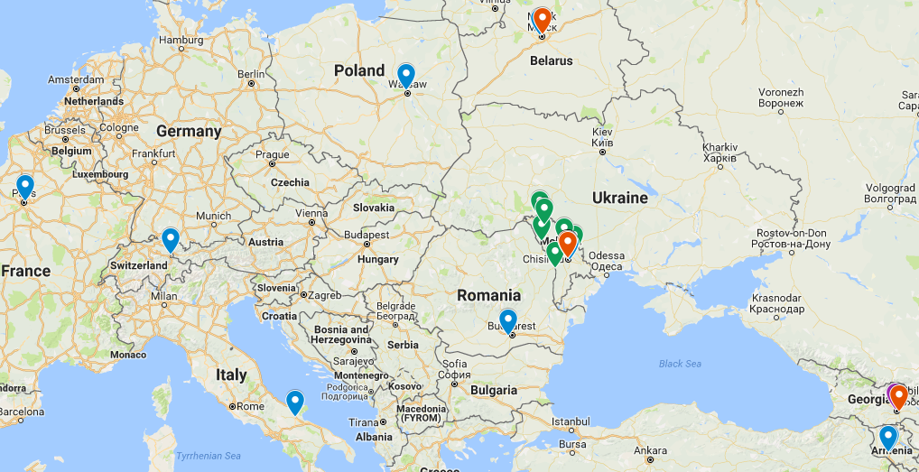
Fig. 1. Visited Enterprises embedded on a Google Map.
The link to the map on Google Drive:
https://drive.google.com/open?id=1Myo1vTV9PP5UircgQ5el062yt_I&usp=sharing
After choosing a marker on the map, all information from the survey filled during visit to this enterprise is showed next to the map (Fig. 2).
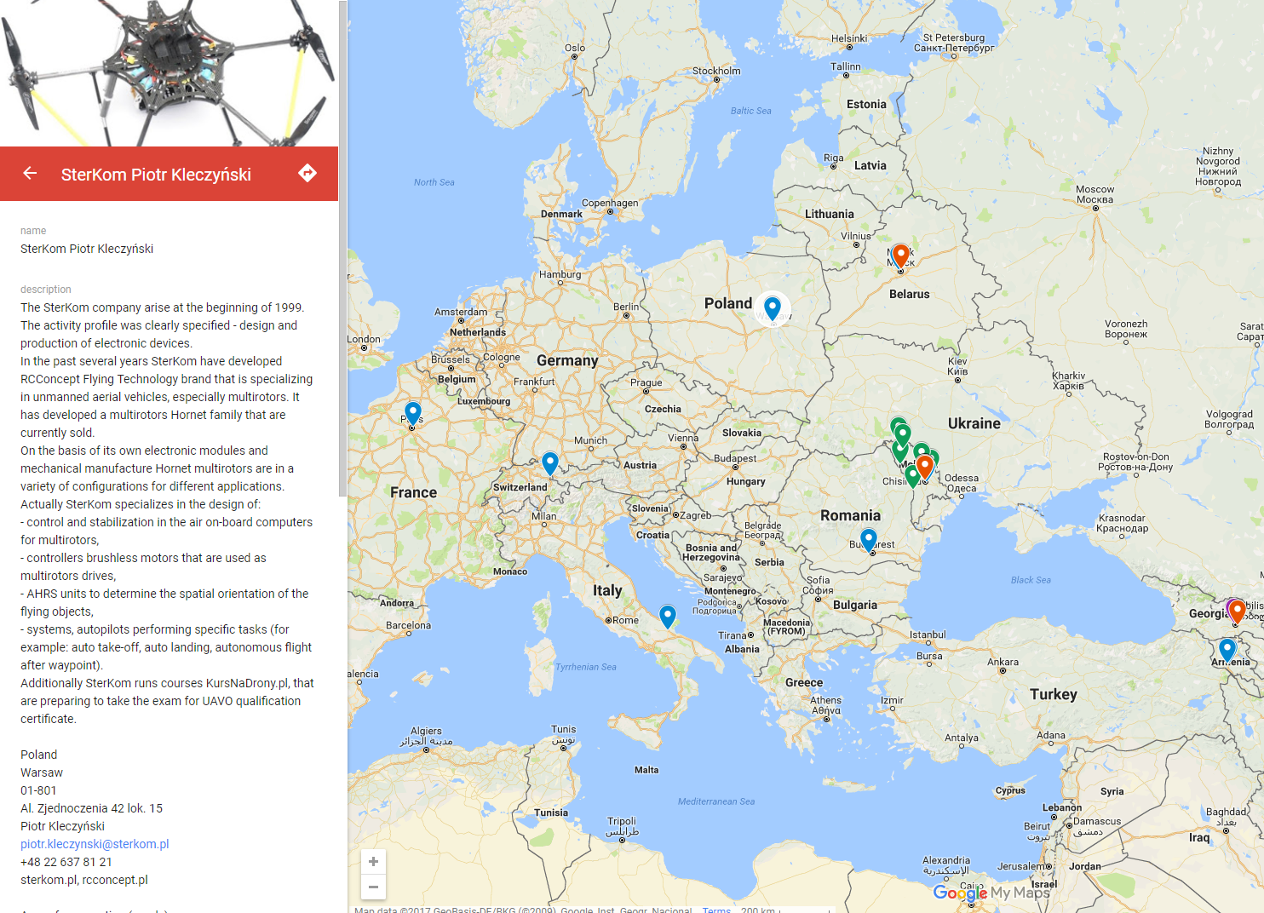
Fig. 2. Information from a survey from visit to enterprise.

Enterprises by category
Enterprises visited in all countries were divided in four categories:
- Drone production:
  - Airworker (Armenia);
  - Instigate Robotics (Armenia);
  - Indela (Belarus);
  - Icevo Consulting (Moldova);
  - Skydrone (France);
  - DPM Elettronica (Italy);
  - SterKom (Poland);
  - AFT Design (Romania);
  - SwissDrones (Switzerland).
- Agriculture (all in Moldova):
  - Crama Domneasca;
  - Dingenarul;
  - Glia-Vito;
  - Agro Girla;
  - Nova-Geea;
  - Vindex-Agro;
  - Vivaj-Agro.
- Public Administration:
  - Scientific and Engineering Republican Unitary Enterprise „Geoinformation Systems” (Belarus);
  - Civil Aviation Agency (Georgia);
  - State Border Police of the Republic of Moldova;
  - Ministry of Transports and Road Infrastructure (Moldova);
  - Institute of Development and Forest Research (Moldova);
  - Tourism Agency of the Republic of Moldova.
- Aerial Photography:
  - Copter (Georgia);
  - Temporary publishing house «Молдавские ведомости» (Moldova).

Drone production
Enterprises from Drone production category were spread all over the Europe (Fig. 3). The primary aim of visits to enterprises was to visit only enterprises producing drones or equipment used by drones in Partner countries. But only four such companies were found. Two in Armenia and one in each Belarus and Moldova. That is why also Program country institutions visited some companies involved in drones’ technology. Altogether 9 enterprises were visited, but only from 7 surveys were obtained. In Table 1 some information from surveys were compared. Most of those enterprises have a well developed list of available products and services. Two of them additionally to selling drones and their equipment train UAV operators.
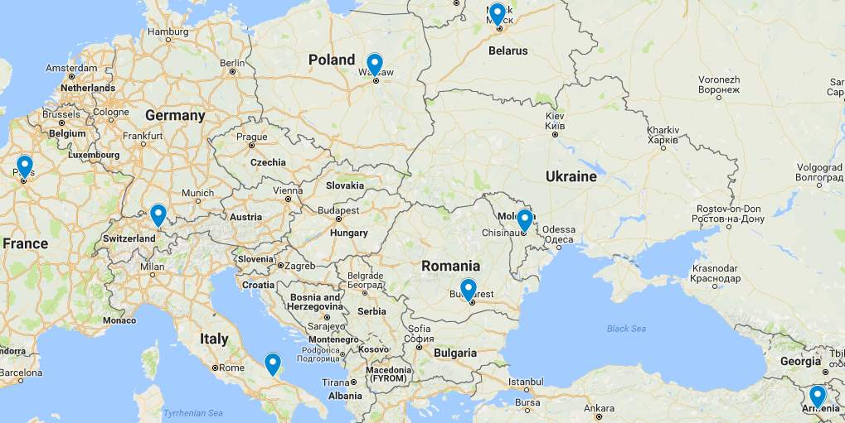
Fig. 3. Enterprises from Drone production category
Table 1. Comparison of enterprises producing drones.
 | Enterprise | Country | Est. | Products | Other activities
1 | Airworker | Armenia | 2016 | Smart Save System Dron | -
2 | Instigate Robotics | Armenia | 2013 | VTOL and fixed-wing UAVs;  Copters with custom architecture;  Autopilot;  Mobile Watchtowers. | Education Laboratory;  Pilot and technician training.
3 | KB Indela | Belarus | 1996 | Helicopters, multirotors,  fixed-wing UAVs;  Ground Control Station;  HIL Simulator;
4 | Icevo Consulting | Moldova | 2008 | High speed multirotor drone;  Flight controller;
5 | Skydrone | France | 2011 | Drone for photography and video  Drone for blood transportation  VTOL quad plane  Heavy lift multirotor (25 Kg)  Tethered drone
6 | SterKom | Poland | 1999 | Multirotors;  On-board computers - Autopilots  Brushless motors controllers  AHRS units | Drone pilot training.
7 | AFT Design | Romania | 2004 | Portable Ground Control Station;  Fixed wing UAVs

Aerial Photography
Although Aerial Photography (Fig. 4) seems to be most popular area of drones usage only two enterprises in this category were visited. Probably this category was not explored more because this destination is obvious, well described and does not require specialy designed drone. Enterprise in Moldova is a newspaper publishing house that is interested in expanding and obtaining more interesting shots using drones and is willing to participate in eDrone course. Whereas enterprise in Georgia is a leading Aerial Photography and Filming company, which also distribute and repair DJI drones as well as train drone pilots.
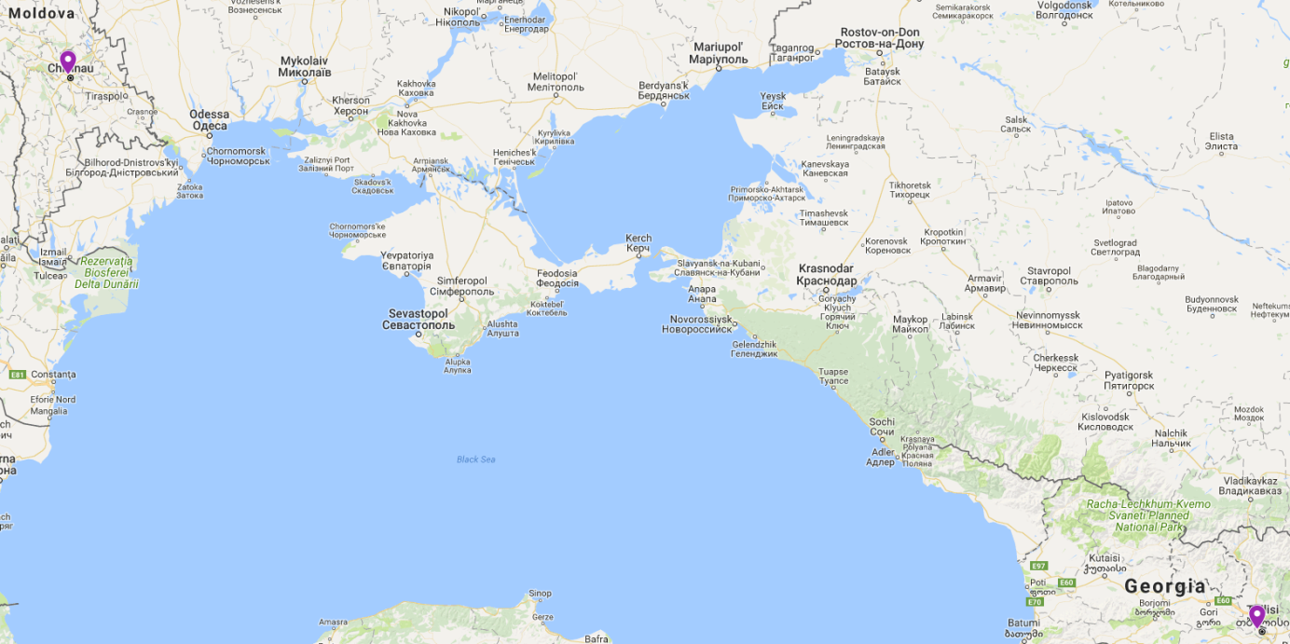
Fig. 4. Enterprises from Aerial Photography category.

Agriculture
All seven companies from Agriculture category were visited in Moldova (Fig. 5). All of those companies are interested in using drones in their enterprises, and are interested in joining the eDrone course to train their employees in that area.
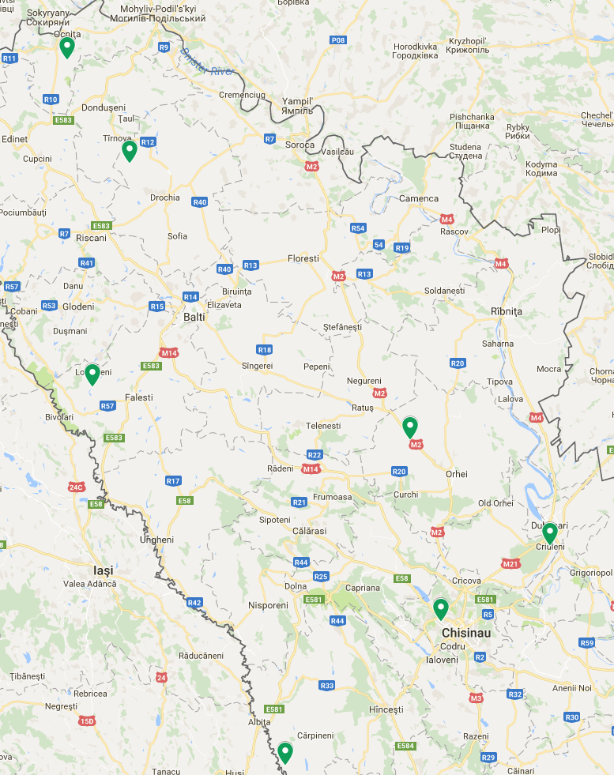
Fig. 5. Enterprises from Agriculture category.

Public Administration
Enterprises from Public Administration (Fig. 6) category visited during this project are the most diversified. In Georgia it is Civil Aviation Agency that is currently finalizing law for using drones that corresponds to EASA project of regulations in this area. In Belarus it is the Scientific and Engineering Republican Unitary Enterprise "Geoinformation Systems" funded of ther National Academy of Sciences of Belarus, which is accumulating all information about using drones in Belarus. In Moldova four public administration enterprises were visited:
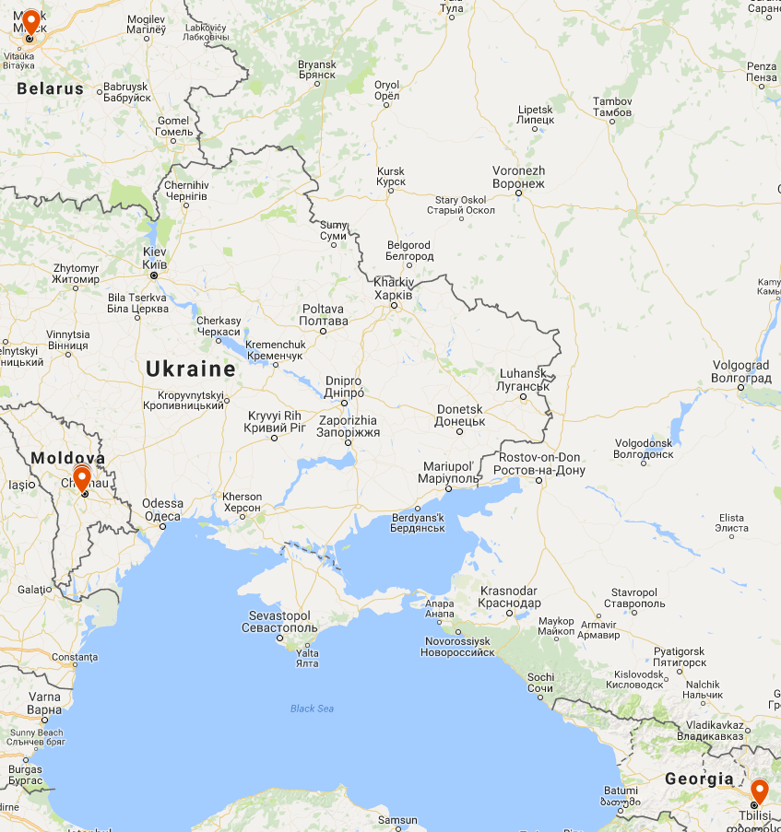
Fig. 6. Enterprises from Public Administration category.
State Border Police, Ministry of Transports and Road Infrastracture, Institute of Development and Forest Research and Tourism Agency. Each of them is interested in using drones equipped with various cameras as monitoring, survailance, indentyfy and detect equipment.

Enterprises by country
Five of the enterprises were in Program Countries, and from Partner countries two in each Armenia, Belarus and Georgia, whereas the rest, and the majority (13) in Moldova. In almost all of the Countries most companies were located in capital cities.

Armenia
Partners from Armenia visited two enterprises that produce drones (Fig. 7). The first, Airworker is a startup established in 2016 and is commercializing of their first product Smart Save System Dron. The second, Instigate Robotics, have just four years of experience, but already can offer few tested and applied UAVs. What is more they teach courses for drones pilots and technitians. Both enterprises became associated partners of the eDrone project.
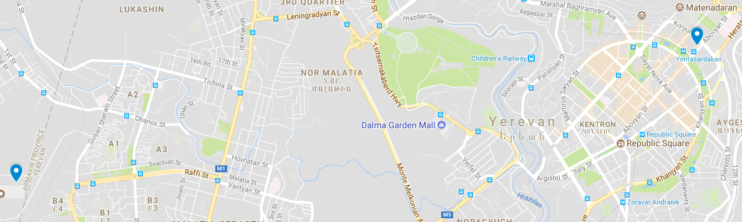
Fig. 7. Enterprises from Armenia.

Belarus
Each partner from Belarus visited one enterprise (Fig. 8). Belarusian State Technological University visited Scientific and Engineering Republican Unitary Enterprise „ Geoinformation Systems”, which is mainly working in the field of Earth Remote Sensing and GIS-Technologies, but is also accumulating all information about using drones in Belarus. The company is interested in Implementation of Drones into the spheres of forest industry, housing management, land management and gas-system monitoring.
Belarusian State University visited KB Indela enterprise that has been producing drones already for over 20 year. It has in the offer numerous helicopters, fixed wings and multirotors, as well as training, test and monitor systems for operators and technicians.
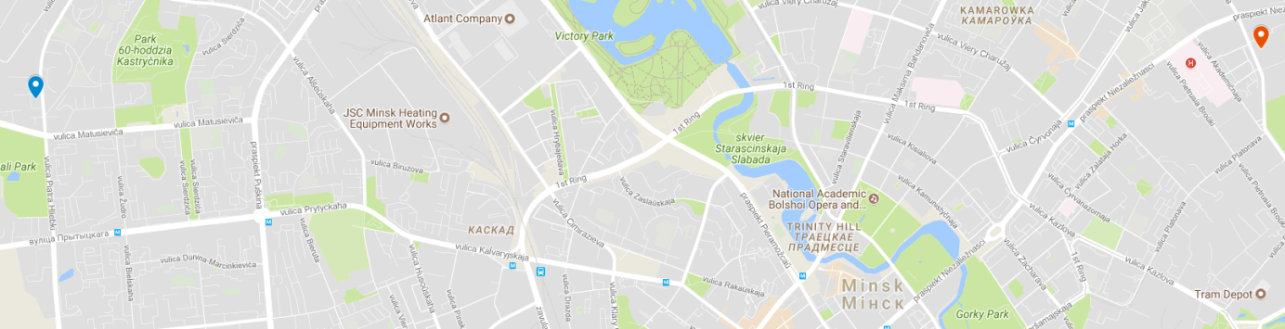
Fig. 8. Enterprises from Belarus.

Georgia
Only in Georgia partners couldn’t find any enterprises that produce drones. There were a few early stage startups, but did not have at that point any prototype yet. That is why one public administration and one aerial photography companies were visited (Fig. 9). The first one is a Civil Aviation Agency that is currently finishing laws for using drones in Georgian Airspace. The second is Copter a leading Aerial Photography and Filming Enterprise in Georgia, which also train drone pilots, distribute DJI drones and repair UAVs. Both enterprises became associated partners of the eDrone project.
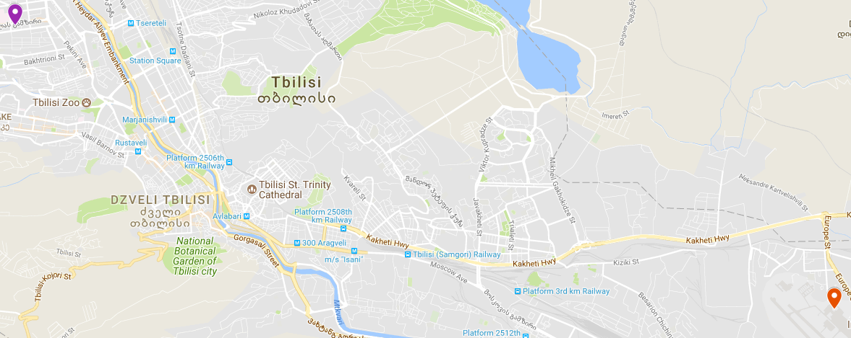
Fig. 9. Enterprises from Georgia.

Moldova
In the eDrone project 5 partners are from Moldova, but only three of them visited enterprises. Nevertheless they have visited the majority - thirteen companies, from all categories (Fig. 10). State Agrarian University of Economics visited seven Agriculture companies that showed interest in deployment drones in their enterprises. Those companies were spread all around Moldova, whereas the rest were in Chisinau (Fig. 11).
Academy of Public Administration interviewed 12 public institutions from which half responded positively, but only 3 surveys were filled. Institute of Development and Forest Research is already using drones for remote sensing but would like to collaborate on improving the usage of visible spectrum cameras. Tourism Agency and Ministry of Transport ans road infrastructure is interested to use drones for tourist site record-keeping, disaster prevention and safty of difficult areas.
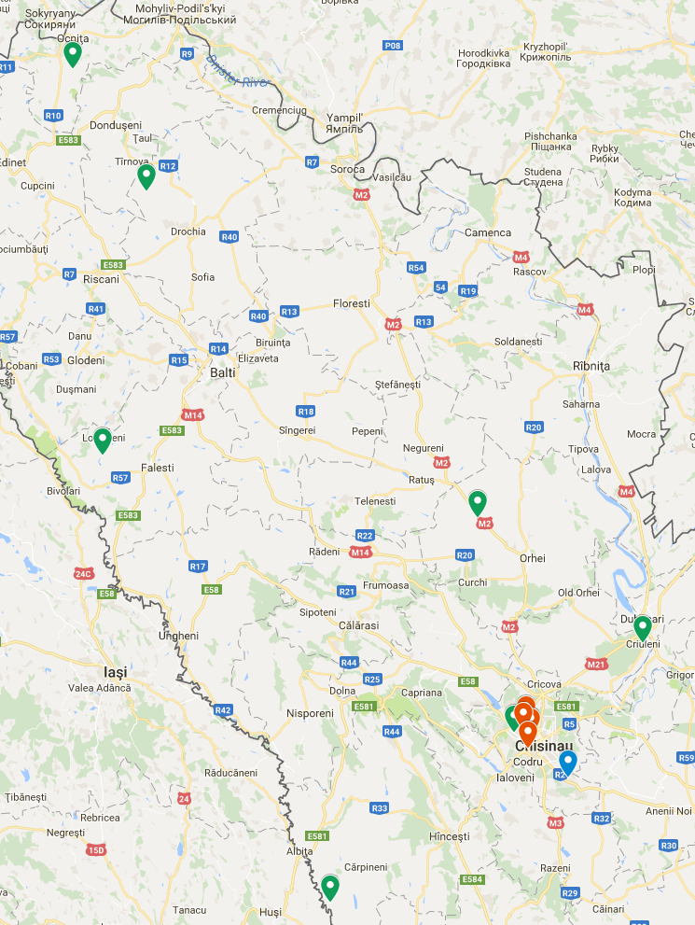
Fig. 10. Enterprises from Moldova.
Moldova State University visited three enterprises from three categories. State Border Police from public administration, Temporary publishing house from aerial photography, and Icevo Consulting, probably the only enterprise in Moldova that produce drones. The first two companies are interested in using drones respectively for border surveillance and taking more interesting pictures for the paper. Icevo Consulting does not have numerous products but has already developed and patented an octocopter Ptera, high speed drone with their own Flight controller, GPS module and IMU sensor.
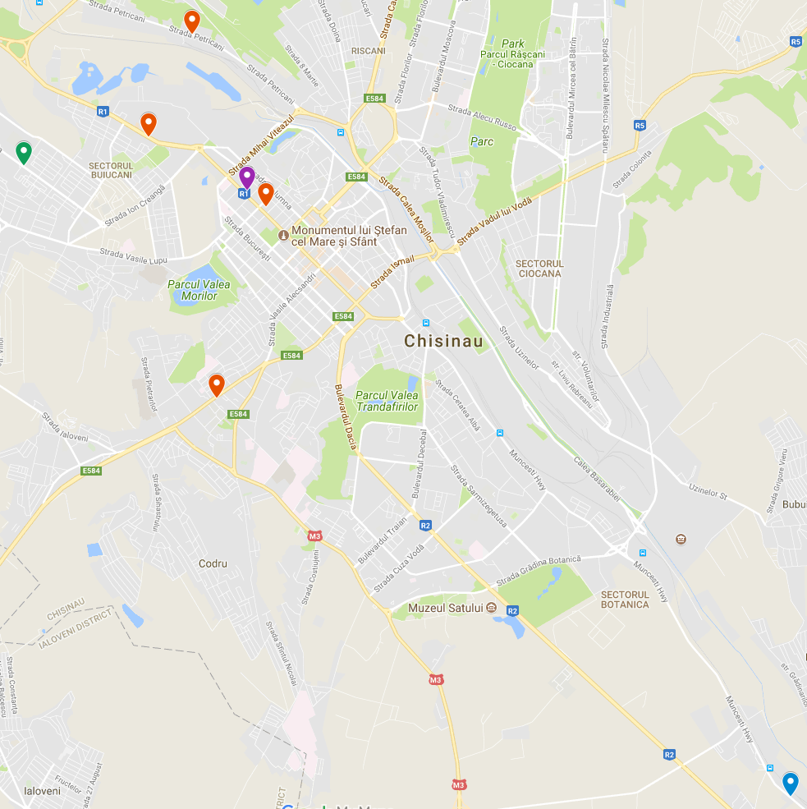
Fig. 11. Enterprises from Chisinau (Moldova).

Program Countries
Each of the project partners from Program Countries has visited one enterprise that produces drones or equipment for drones (Fig. 12). Two institutions from Romania visited the same AFT Design company which is the biggest enterprise that produce drones for civil application in Romania. French company B4Eng went to Switzerland to visit SwissDrones, while University of Evry got only one positive response from Skydrone company after their inquires about visits. The similar was with Military University of Technology and University of Sannio that got invitation for visits only from companies with which they already coparate.
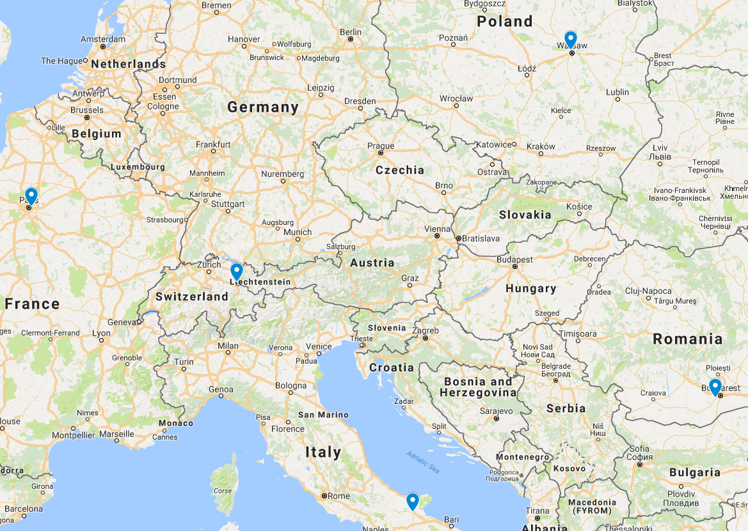
Fig. 12. Enterprises from Program Countries.

Conclusion

During a visit to twenty-four enterprises twenty-one surveys were filled. The visits showed that in Georgia and Moldova drones technologies are not developed but there is a need to use them in various areas. In Armenia two emergent enterprises were visited that produce drones and are involved in popularizing this technology. In Belarus drone market seems to be well established as a company with over 20 years of expertise in the drone production was visited, but the lack of separate law for drone usage seems to be a most urgent user need. Accordingly to the surveys, a list of entrepreneurs’ needs was obtained, that was divided in two types of skills: technological and practical (Table 2). This list will be used for the final report in Work Package 1 on user needs, as well as will be taken into account in the preparation of the "Civil applications" module as well as in other modules within the CTT and CTI.
Table 2. Entrepreneurs’ needs.
Technology skills | Practical skills
Specific payload development:  LIDAR, SAR radar; Multisensorial payload; HD video datalink; UAV Handover technologies; Sense and avoid; UAV transponder | Drones using with cameras (infrared and infra-violet) spectral chambers for the evaluation of hunting stock.
Safety of flying equipment | Soil testing,
Dedicated flying platforms for research and academic purposes | Silvo-pathological monitoring to determinate the outbreaks and pests;
Software development | Field screening,
Autopilot development | Agricultural land maps
Aeronautic certification for UAS | Plant monitoring,
 | Disease prevention,
 | Elaboration of land maps.
 | Surveying plantations.
 | Monitoring of the phytosanitary statment of the vineards
 | Safeqarding the vinyards
 | To optimize costs for border monitoring.
 | To organize online broadcast of public events on the portal (photos and movies)
 | To collect information about current events.
 | To cover larger event area for photo and video record.
 | To minimize health risks for photographers and journalists during the protest actions.
 | To count the number of people at the event.
 | To realize fast delivery of printed products to subscribers.

